This directory contains the Matlab code and test data for plotting track of a segmented object in a time lapse movie. To apply this, one must first have documentation of the object’s coordinates at each time point (such as in the excel file attached).

How to use Plot_XY_over_time:

1. As the first line, enter the coordinates as a two-dimensional matrix. This can be done by copying the two columns from excel and pasting inside the square brackets. The matrix should look like this: A=[Xcm;Ycm]
2. In the following loop, enter the number of time points (for example, in the current code i=180 minutes)

*You should be able to see the matrix A, and the center mass coordinates in Matlab workspace.

3. Run. You should receive a Figure (see below) which shows the track coordinates in the overall

field of view. The track is time coded and can be magnified and saved as image.

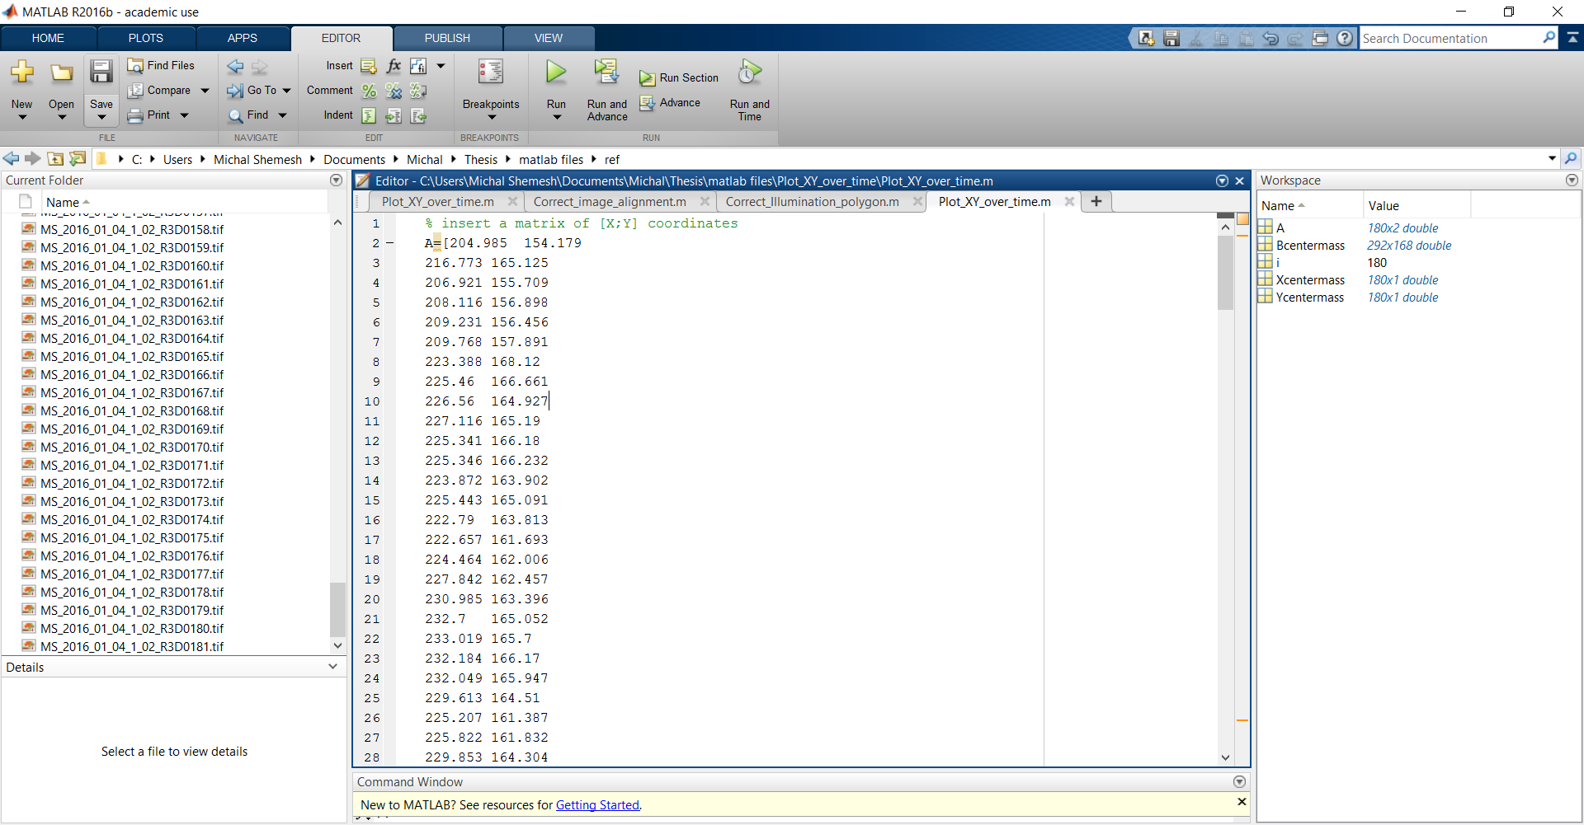

Fig.1: Snapshot of Matlab command window. Red rectangular marks the matrix “A” as it should be inserted (step 1).

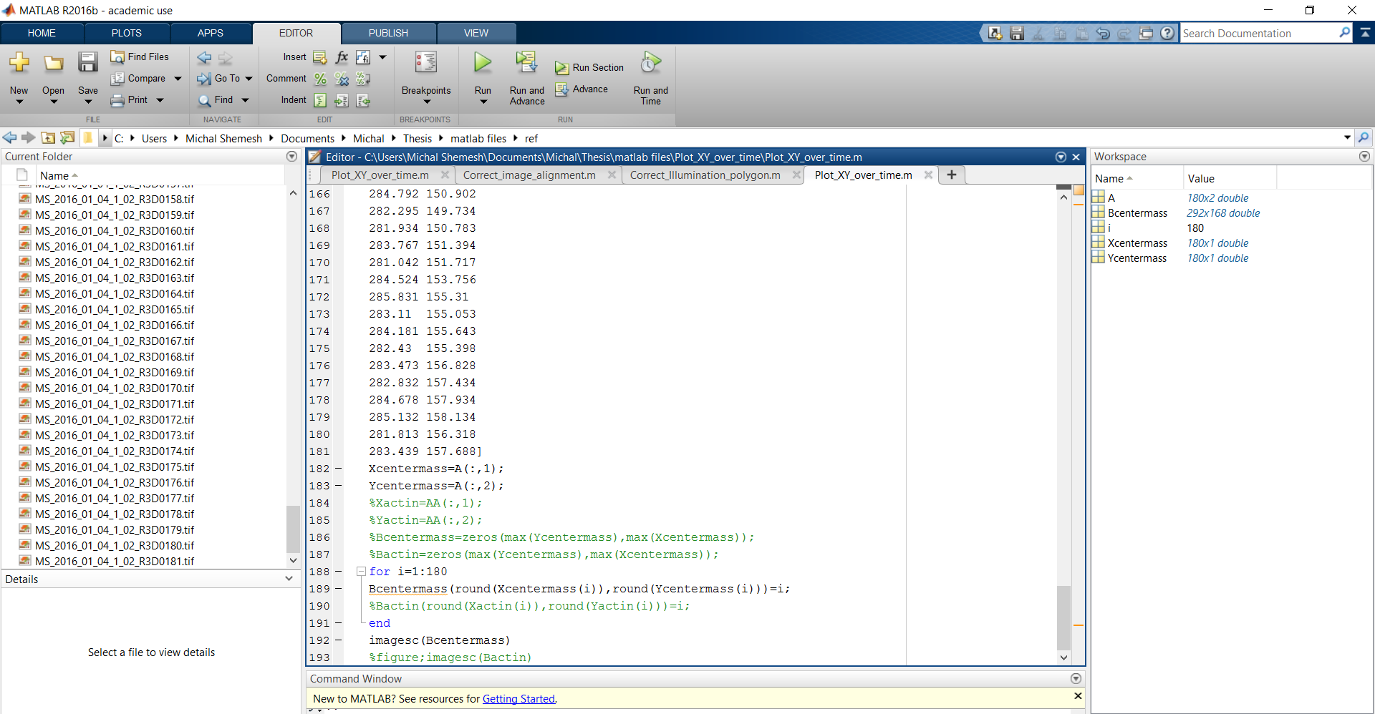

Fig. 2: Snapshot of Matlab workspace. Red arrow points to the loop where you need to insert the number of time points (step 2).

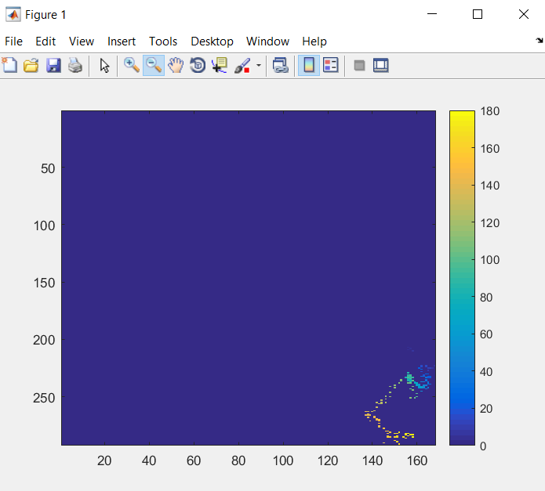

Fig.3: Exemplary image demonstrating the track received..